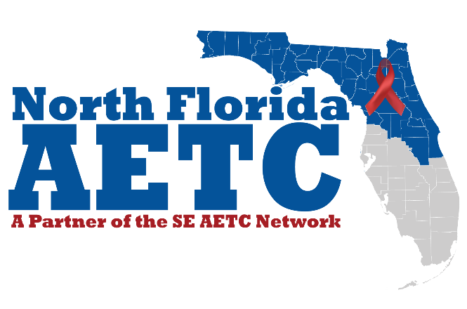
Continuing Education
Policies and Procedures

August 2018

Table of Contents
Contents
General Information 4
Mission Statement 4
Purpose 4
Funding and Operational Policies 4
Target Audience 4
Services 5
Long Range Objectives 5
NF AETC Faculty and Staff 5
Organizational Chart 7
Contact person for Nursing Continuing Education 8
Contact for Pharmacy Continuing Education 9
Contact for Mental Health Continuing Education 9
Operational Policies and Procedures for Continuing Education Programs 9
General Requirements 9
Speaker Disclosures 10
Awarding Credits 10
Determination of Credit Hours 10
Partial Credit 10
Continuing Education Certificates 11
Marketing for events with Continuing Education Credits 11
Continuing Education Record Storage 11
Commercial Support or Sponsorship 12
Grievance Procedures 12
Course Cancellation Policy 12
Post Course and Ongoing Course Evaluations 13
Post- Course Evaluation 13
Ongoing Evaluations 14

General Information

Mission Statement
The mission of the North Florida AIDS Education and Training Center is to improve the care of people living with HIV/AIDS. We believe that every member of the healthcare team has their respective role in this endeavor, and we aim to educate and motivate our colleagues in counseling, diagnosing and treating HIV disease. Working together, we can optimize the management of people living with HIV and prevent the high-risk behaviors that lead to HIV transmission.

Purpose
The North Florida AIDS Education and Training Center (NF AETC) was established on July 1, 2015 to improve the care of people living with HIV/AIDS. We provide education and training opportunities for healthcare providers in the North Florida area, covering the Panhandle down through the I-4 corridor in Orlando. We believe that every member of the healthcare team has their respective role in this endeavor, and we aim to educate and motivate our colleagues in counseling, diagnosing and treating HIV disease. Working together, we can optimize the management of people living with HIV and prevent the high-risk behaviors that lead to HIV transmission.

Funding and Operational Policies
This grant is completely funded through the Health Resources and Services Administration (HRSA) of the U.S. Department of Health and Human Services (HHS) under grant number U1OHA29297 for the AIDS Education and Training Centers funds THE NF AETC. North Florida AETC is a partner site of the SE AETC out of Vanderbilt University’s Comprehensive Care Clinic in Nashville, Tennessee. The SE AETC establishes an annual workplan for its partners to meet goals and requirements set forth by HRSA. It is the job of the partner site to complete all items on the workplan in a timely manner.
Target Audience
The NF AETC’s Continuing Education serves physicians, pharmacists, nurses, and other health care professionals. Our mission is to enhance clinician knowledge and competence; improve clinician performance; and promote lifelong learning for physicians, nurses, pharmacists, and for other health practitioners locally, regionally, nationally and internationally. The ultimate goal of this endeavor is to improve patient care and health outcomes.

Services
We fulfill this mission through the development of educational activities that: address gaps in knowledge, quality or performance; disseminate evidence-based knowledge and skills; employ educational methods that are suitable to the content, topic, and target audience; and are free from commercial bias or influence. We engage in systematic analysis of the value and impact of our educational activities and strive continuously to improve the quality and effectiveness of this work. Examples of activities include but are not limited to, Education programs on all aspect of HIV prevention, diagnosis and management, Capacity building assistance, Practice transformation coaching, Clinical consultation, Workforce education, Technical assistance, and Educational and resource materials.

Long Range Objectives
Long range plan for the NF AETC includes to continue to offer education and training opportunities for continuing education credits to participants over the course of the HRSA grant. In 2016, NF AETC served over 2,000 unique clients through its programing. Each year, we will strive to increase the number of medical participants served by 10% total. The goal is to expeditiously provide continuing education credits to licensed health care professional in the North Florida area so that they can continue providing care to their clients based off best practices. As health care evolves, the course offerings will be reviewed by the committee to ensure they meet these evolving standards and best practices as identified in the literature. Participants will be continually assessed each year to ensure cutting-edge course offerings are provided to medical providers. Target audience will be expanded to meet the needs of the consumer base on a case by case basis. NF AETC will take an interdisciplinary, teams-based approach in training these providers to align with current patient care recommendations.

NF AETC Faculty and Staff
Central office requirement state that Partner Site faculty and staff at a minimum shall consist of a principal investigator (MD degree required), medical director (MD degree required), and a project coordinator (master’s degree required). Additional faculty and staff may be obtained to achieve grant requirements.
The NF AETC is staffed with personnel across interdisciplinary fields in provider care and education pedagogy to provide the most comprehensive approach to its education and training programs. Faculty include professionals in medical education, nursing, pharmacy, and clinical psychology. The selection of faculty will be the responsibility of the NF AETC. Faculty will be selected based on knowledge and expertise in the content area and professional qualifications. Faculty will contribute to the planning, presentation and/or evaluation of the activity as appropriate. At least one faculty member and/or planner must be represented on the advisory committee and/or in the activity. Consultants are obtained as needed to provide area-specific expertise for training participants.
Jennifer Janelle, MD- Principal Investigator
Taryn Buckley, PhD, CHES- Project Manager
Briana Jones- Project Coordinator
Kristina Fletcher- Project Assistant
Ryan Nall, MD- Faculty specializing in internal medicine, primary care and LGBTQ health
Amy Blue, PhD- Faculty specializing in inteprofessional education
Erik Black, PhD- Faculty specializing in inteprofessional education
Joanne Orrick Urban, PharmD, AAHIVP- Faculty specializing in HIV pharmacy
Nicole Ennis Whitehead, PhD- Faculty specializing in HIV clinical psychology, Mental Health and Substance Abuse
Deborah Cestaro- Seifer, RN, MSN- Faculty specializing in HIV nursing, motivational interviewing
Mark Schweizer, DDS MPH- consultant specializing in HIV Dentistry
Beth Gadkowski, MD- Faculty specializing in PrEP/ PEP, Tuberculosis, Rural HIV Healthcare, Ryan White Healthcare Services
Vidhu Kiryawasam, MD- Faculty specializing in PrEP/ PEP

Organizational Chart
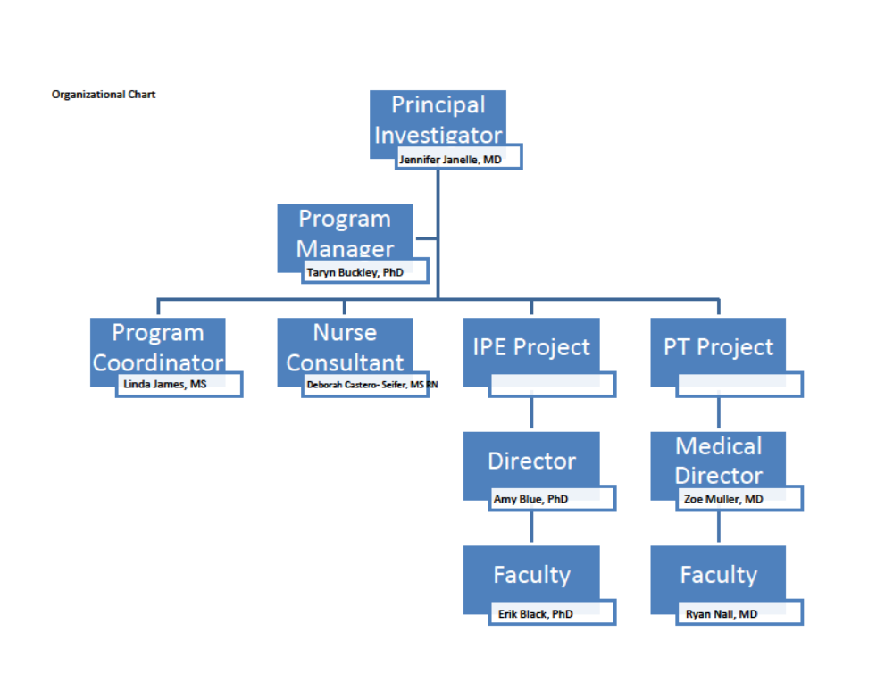

Directors of Continuing Education Programming
Jennifer Janelle, MD
Principal Investigator | Infectious Disease Physician
Dr. Jennifer Janelle serves as an assistant professor for the University of Florida’s Division of Infectious Disease and Global Medicine. Additionally, she is the director of the fellowship program for the department and is the principal investigator of the North Florida AIDS Education and Training Center (AETC), a partner in the Southeast AETC network. She serves as co‐editor of several SE AETC treatment guideline resources and provides training and education to healthcare providers on a variety of HIV‐related topics. She has more than 15 years of experience providing clinical care to people living with HIV infection. Currently, she provides patient care at the University of Florida, Gainesville, Infectious Diseases Clinic as well as at Ryan White funded HIV clinics in rural areas of North Florida.
Taryn Buckley, PhD, CHES
Project Manager | Assistant Director of Education and Training
Taryn Buckley, PhD, CHES is the Program Manager of the North Florida AIDS Education and Training Center. She manages grant activities including creating trainings and preceptorships, and reporting education and training activities. She coordinates all project efforts and contacts for the IPE and PT projects. Dr. Buckley, a certified Health Education Specialist, also provides periodic trainings on HIV epidemiology, routine testing and motivational interviewing.

Contact person for Nursing Continuing Education
Deborah Cestaro-Seifer, MS RN
Nurse Consultant | Education and Training Specialist
Ms. Cestaro-Seifer has more than 35 years of mental health and chronic disease management experience. She has provided care and treatment to individuals living in the rural mountain communities of Tennessee, North Carolina, and Virginia. Additionally, she served as Assistant Professor of Nursing at the University of the Virgin Islands from September 2007 through July 2012, where she taught psychiatric and geriatric nursing. Ms. Cestaro-Seifer has coordinated numerous clinical research studies and published articles in the field of tobacco intervention/cessation and pulmonary rehabilitation. From 2012 through 2015, Ms. Cestaro-Seifer was the Project Coordinator for the Florida/Caribbean Telehealth Education Training Center, was a faculty member with the Florida/Caribbean AIDS Education and Training Center (F/C AETC) and Coordinator of the Expanded Testing Initiative. In 2015, she began working with the NFAETC. In her 12-year history of working in the field of HIV/AIDS, she presented on topics such as engagement and linkage to care in numerous educational sessions and workshops. Ms. Cestaro-Seifer has extensive knowledge of patient activation and HIV self-management, behavioral health screening instruments, cultural leveraging to promote engagement, health disparities and healthcare access, talking about sexual health, HIV testing, and motivational interviewing strategies to promote health behavior change.

Contact for Pharmacy Continuing Education
Joanne Orrick Urban, PharmD, AAHIVP
NF AETC Faculty | Clinical Pharmacist
Dr. Orrick is a Clinical Pharmacist with the North Florida AIDS Education and Training Center (AETC), a partner of the Southeast AETC network. She has more than 15 years of clinical experience in Infectious Diseases and HIV pharmacotherapy. She has been a faculty member of the AETC in Florida since 1998 serving as co-editor of several treatment guideline resources and providing training and education to healthcare providers on a variety of HIV-related topics. She provides clinical pharmacy services at a rural Ryan White funded HIV clinic and at an HIV/AIDS specialty pharmacy.

Contact for Mental Health Continuing Education
Nicole Ennis Whitehead, PhD
NF AETC Faculty | Clinical Psychiatrist
Dr. Nicole Ennis Whitehead is an Assistant Professor in the Department of Clinical and Health Psychology in the College of Public Health and Health Professions. Dr. Whitehead received her Ph.D. from Kent State University in 2001 (Clinical Psychology, Health Psychology Track). She completed an APA approved internship at the University of Miami/Jackson Memorial Hospital. Her internship focused on the psychosocial aspects of treatment for Cancer, Renal and Trauma patients and their families. Dr. Whitehead completed a research fellowship at the University of Miami on an NIMH-funded training grant, “Biopsychosocial Processes in Immunology and HIV/AIDS Research.” Dr. Whitehead’s fellowship work focused on the intersection of Cancer and HIV, through the examination of HPV, an oncogenic virus, stress and cervical cancer progression in HIV+ women.

Operational Policies and Procedures for Continuing Education Programs

General Requirements

The overall activity goal, educational objectives and content will be determined by the NF AETC, the activity director and/or the activity advisory committee members and lead planners. All CE activities must be reviewed by and planned in conjunction with the NF AETC. As the accredited provider, NF AETC assumes responsibility for the content validity and integrity of an activity.
When applicable, a providership agreement, generated by NF AETC, must be signed by all educational partners, defining the responsibilities for activity planning, administration, documentation requirements and budget management prior to the activity. A NF AETC Educational Activity Planning Form must be utilized for each activity and accompany the providership agreement.

Speaker Disclosures
- All faculty, planning committee members, and other persons in a position to control the content of an activity must return a resume/ curriculum vitae in addition to a signed Disclosure Form to the NF AETC prior to the activity date. If it is determined that a conflict of interest exists, it will be addressed and resolved by the course director, the medical director and the nurse planner (when applicable and as appropriate), prior to the start of the activity. All information will be made available to participants prior to the start of an activity. If those in a position to control the content of an educational activity refuse to disclose relevant financial relationships, they will be disqualified from being a part of the planning and/or implementation of the activity.

Awarding Credits

Determination of Credit Hours
- The number of contact hours or CEUs to be awarded for participation and successful completion of an activity shall be determined by the provider in advance of offering the activity and comply with the requirements set forth for the types of continuing education activities (knowledge-, application- and practice-based).
- Live CE activities: CE credit is based on real time, i.e. 60 minutes = one (1) contact hour (0.1 CEU) spent in completing the activity.
- Enduring CE activities: An enduring material is a printed, recorded, or computer-presented activity that may be used over time at various locations and which, in itself, constitutes a planned activity. In an enduring material, the provider creates the content. Maximum amount of credit that can be earned on these types of activities will be listed clearly under the event posting.
- Successful completion of an activity will be determined by NF AETC but will include:
  - Sign-in to an activity (roster must include title and date of the activity, and the following participant information: full name typed or in print, full signature and phone/email address)
  - Full or partial attendance
  - Completion of activity evaluation

Partial Credit
The policy on the granting of partial continuing education credit is that the planning committee shall make the determination whether partial or no credit shall be granted when an attendee arrives late, leaves early or otherwise misses a portion of the continuing education program.

Typically, we will grant partial credit only when the duration of the attendee’s absence and the content missed does not substantially diminish the educational value of the continuing education program to the attendee. If the planning committee determines that absences of longer than a specified period of time, for example one hour, or absences during certain portions of the program, for example, the last hour, will result in no credit. If the decision to grant partial credit is determined, participant actual attendance will be tracked and certificates will be provided to attendees with continuing education credits based on actual hours attended, rounded down to the nearest half hour.

Continuing Education Certificates
Verification of participation and/or certificate of successful completion for a continuing education activity must be signed by one of the continuing education directors of NF AETC. CE certificates will be distributed on-site, mailed, emailed, or made available to participants online, after the required materials are submitted, i.e., completed evaluation, post-test, etc.

Marketing for events with Continuing Education Credits
All print/marketing materials (i.e., brochures, flyers, journal advertisements, syllabi, evaluation forms, etc.) and web-based materials will be developed with and reviewed by the NF AETC prior to printing.

Print, marketing and web-based materials will include required accreditation language, provided by NF AETC. Information cannot be printed, launched, or distributed until NF AETC has reviewed and approved the information.

Continuing Education Record Storage
Complete records are kept on file by the NF AETC for a minimum of six (6) years. The provider shall maintain and assure the availability of records adequate to serve the needs of the learners and others requiring such information for a period of six years. The provider should assure the security of its records by having appropriate backup systems and contingency plans. All electronic documents will be stored in a secure drive that only authorized faculty and staff can access. Paper documents will be kept for the minimum term requirement and then shredded at a secure facility.

Commercial Support or Sponsorship
Commercial interests may not be involved in activity planning, implementation, evaluation, or faculty selection.
Commercial support must be provided as an unrestricted educational grant and must be accompanied by a signed commercial support agreement. All commercial support must be acknowledged in the activity materials and made known to participants in advance of the educational activity.

Grievance Procedures
NF AETC is committed to conducting all activities in strict conformance with accreditation agencies and boards. NF AETC will comply with all responsibilities to be nondiscriminatory in activities, program content, and in treatment of participants. The monitoring and assessment of compliance with these standards will be the responsibility of the Principal Investigator, Project Manager and members of the Continuing Education Planning Committee.
While NF AETC attempts to assure fair treatment of all participants, we recognize grievances that may require intervention. Grievances are handled in the following manner:

When a participant, either orally or in written format, files a grievance, the Principal Investigator, Project Manager and members of the Continuing Education Planning Committee, will evaluate the nature of the complaint. If it is meritorious, the Principal Investigator, Project Manager and members of the Continuing Education Planning Committee, will instruct the staff to implement any necessary changes in the course. The complainant will receive a response from the Principal Investigator, Project Manager, or designated staff within 5 working days.

Grievances can be filed by telephone or email. Telephone #: 352-273-7845 Email: aetc@medicine.ufl.edu

Course Cancellation Policy
NF AETC reserves the right to cancel an activity at any time prior to the start date of the course. Participants can cancel their participation by contacting staff via phone or email.

Post Course and Ongoing Course Evaluations

Post- Course Evaluation
All activities must be evaluated upon the completion of the activity and 8-10 weeks post activity. Participants can complete either an electronic survey distributed via email, or a paper evaluation onsite at the conclusion of the event.

Sample evaluation questions:
Please evaluate the following (Likert scale)
- How would you rate the OVERALL rating of the program?
- Rate your level knowledge on the content presented BEFORE training.
- Rate your level knowledge on the content presented AFTER training.
- Rate your ability to apply the content presented in your work setting
Please rate each presenter on the following areas (Likert scale):
- The objectives of the training were clearly communicated at the beginning of the event.
- The presenter was responsive to participants’ questions and concerns.
- The content was well organized and clearly presented.
Please answer the following:
- What was the single, most important thing or takeaway that you learned from this session? (open-ended, free text response)
- Are you able to apply this knowledge or skill in your work setting? (yes/no/N/A)
- How are you able to apply or what barriers do you see in applying the techniques learned or information gathered in your work setting? (open-ended, free text response)
- What did you like most about this event? (open-ended, free text response)
- What would you change about this training? (open-ended, free text response)
- Please list any other HIV related training needs. (open-ended, free text response)
- Was this activity free of commercial bias or influence? If no, explain. (Yes/ No, then open-ended, free text response)

Ongoing Evaluations
Needs assessment data from multiple sources must be used to plan and evaluate all educational activities. Assessment and review of the identified target audience’s educational needs is a required step in the activity planning process. Learner needs determine the goals and objectives and content to be covered.
Based on adult learning principles and active learning methods, all course directors and faculty are encouraged to actively engage participants to the best of their ability in NF AETC Policies and Procedures, conjunction with appropriate format and assess participant learning before, during and after the educational activity.
As health care evolves, the course offerings will be reviewed by the committee to ensure they meet these evolving standards and best practices as identified in the literature. Participants will be continually assessed each year to ensure cutting-edge course offerings are provided to medical providers. Target audience will be expanded to meet the needs of the consumer base on a case by case basis. NF AETC will take an interdisciplinary, teams-based approach in training these providers to align with current patient care recommendations.

